**ECE 2305**

**Introduction to C Programming**

**Programming Project 05**

**One-dimensional Arrays**

Write a C++ program that will create an array of type **double** numbers with a given number of elements. Use the number of elements **const int size = 10** for demonstration purposes, but write the program where the size of the array can be changed by changing the value of one constant. Fill the array with random type **double** numbers between 0 and 100 using the expression **rand()%100** to generate the numbers. Write the program to present options to the user as a menu and perform the following operations:

1. Create a new array with random elements.

2. Display the elements of the array.

3. Find and display the largest value in the array.

4. Find and display the smallest value in the array.

5. Sort the array in descending order and display the array.

6. Find and display the mean value.

7. Find and display the median value.

8. Find and display the variance.

9. End

Each operation shall be written as an individual function. Pass the array address to the functions and the **size** of the array.

Document the program with a document with the following sections:

1. A written description of the purpose of the program and a description of the program structure.

The purpose of this program is to create an array and complete different operations on it. It uses user defined functions for the menu options, a do while loop, and a switch structure to complete this objective.

B. A diagram that illustrates the structure of the program.

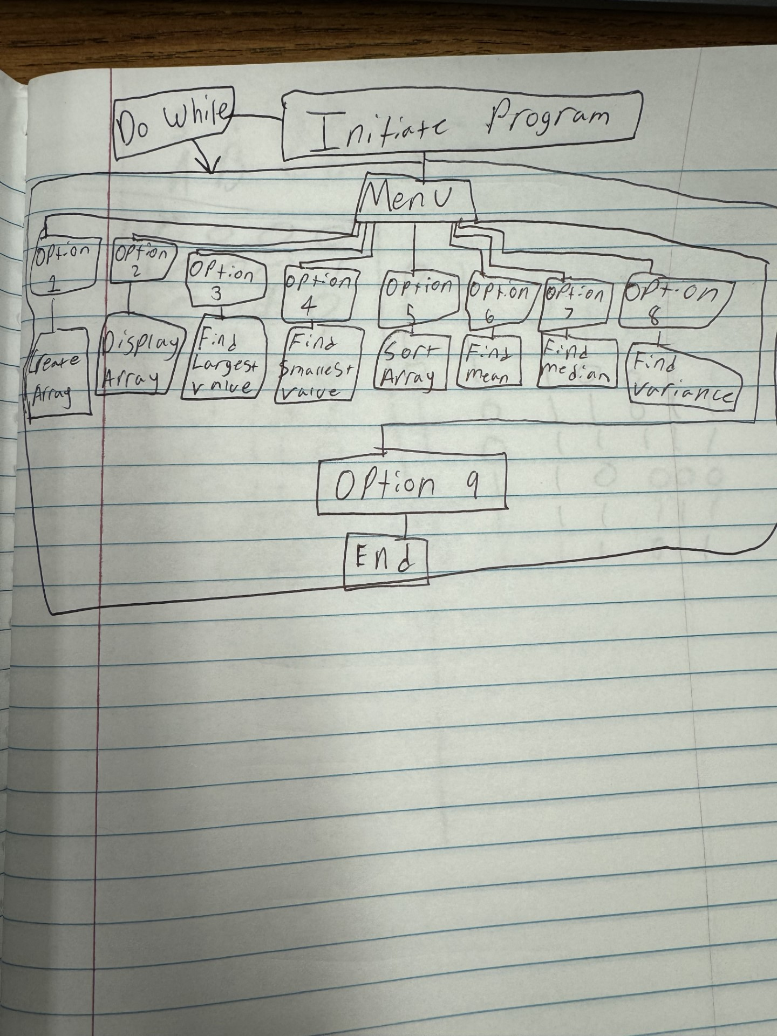

C. The code listing.

D. Screen shots showing the results of each operation.

